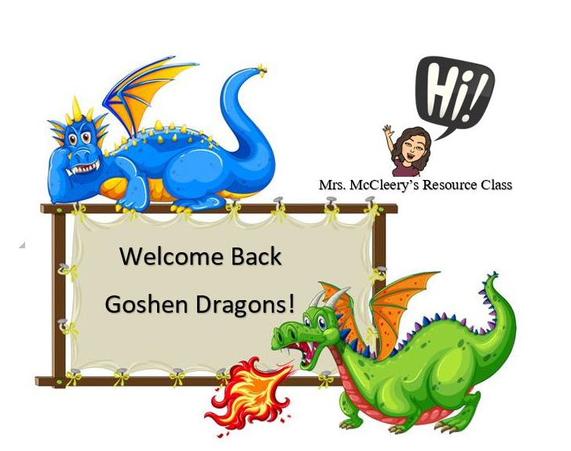

Welcome back to school!

I am so excited about this new school year and the opportunity to work with you and your child! My name is Mrs. McCleery and this is my 27th year teaching in Richmond County. I am currently Co-teaching 5th Grade Math and Collaboration 2nd Grade Math. My goal is to support your child according to their needs so that they can be academically and socially successful.

If you have and questions, please email me at [mccleje@boe.richmond.k12.ga.us](mailto:mccleje@boe.richmond.k12.ga.us) or call the school at 706-796-4646 and I will return your call as soon as possible. Together we can make this a great year for your child!